Task on Terraform-6
1). Watch the Terraform-06 video.
Completed watching video
2). Execute the script shown in the video.
First lets create a folder inside our project
Inside aws_instance, create these files:
Main.tf
Variable.tf
Let’s write a resource block for ec2 and variable block for ami
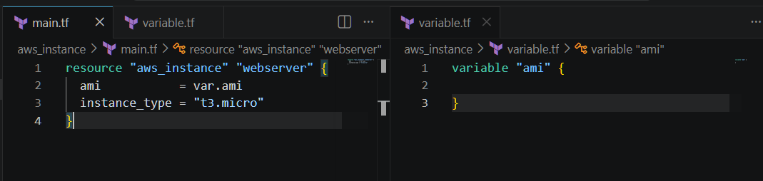
Now let’s create another folder call development inside our project
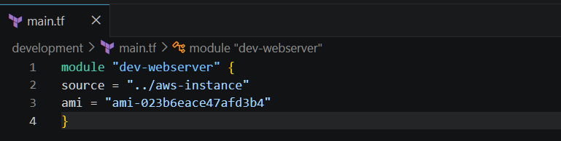
Now go to development folder and perform terraform init and terraform apply
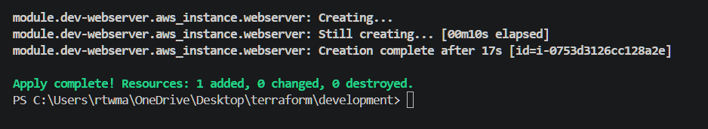

Instance created successfully
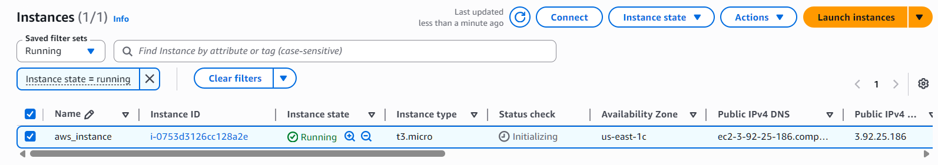
Terraform workspaces allow multiple state files to exist within the same
Terraform configuration. This helps manage different environments such as:
Development (Dev)
Testing (QA)
Staging
Production (Prod)
Each workspace maintains its own Terraform state, ensuring that infrastructure changes in one environment do not affect another.
Lets create a project inside root
- terraform workspace new project-1 creates new workspaces
- terraform workspace list lists available workspaces
- terraform workspace select default switch to default workspace
- terraform workspace select project-1switch to selected workspace
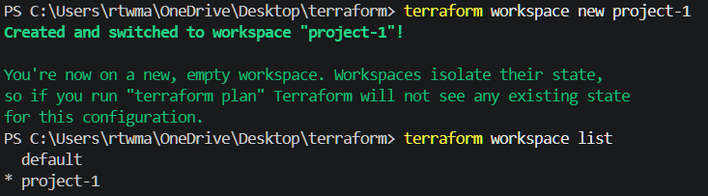
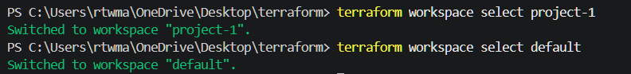

Now update variable.tf to map
Terraform init and terraform apply
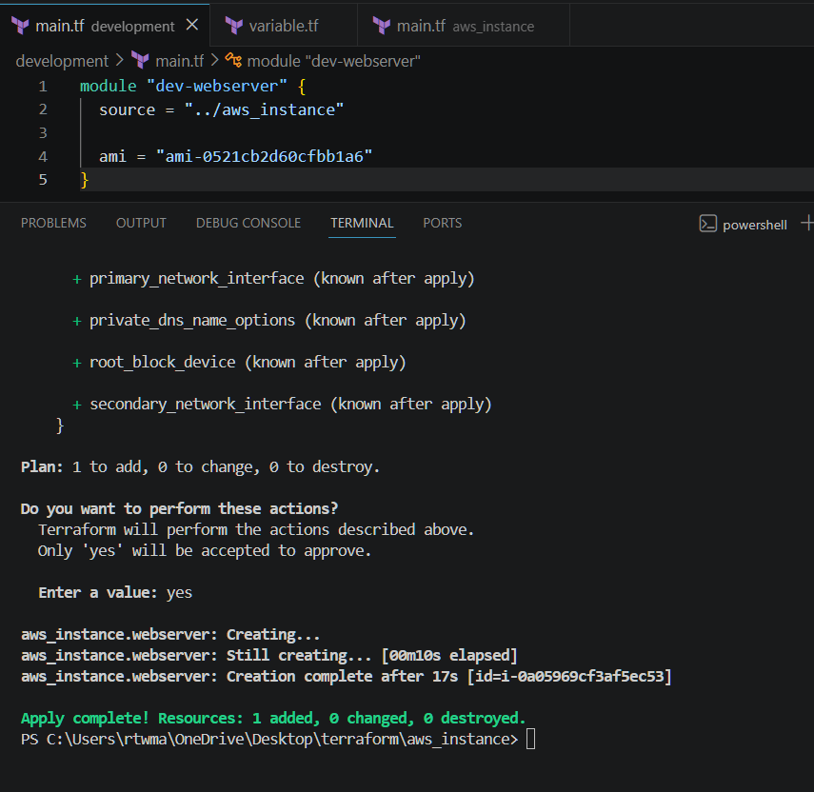
Workspace is added and it is maintaining separate statefile
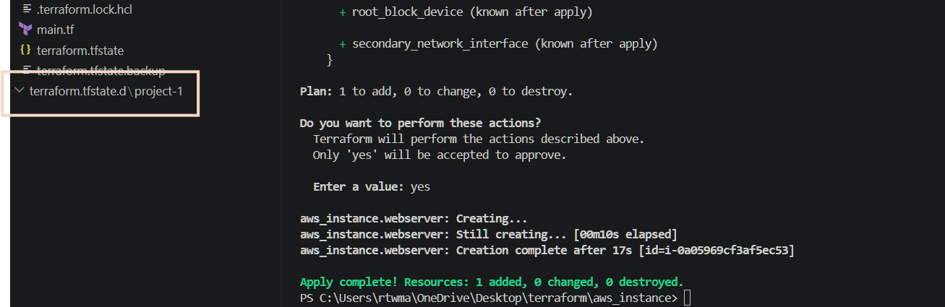
3). Provision EC2, S3, and VPC using Terraform modules.
Let’s create folders
Modules
mkdir vpc
mkdir ec2
mkdir s3
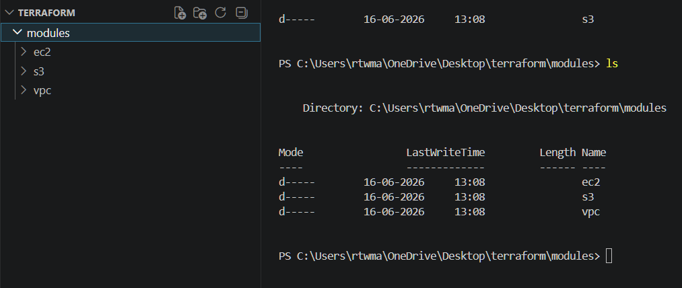
Inside your root project directory (terraform-project), create a file named:provider.tf
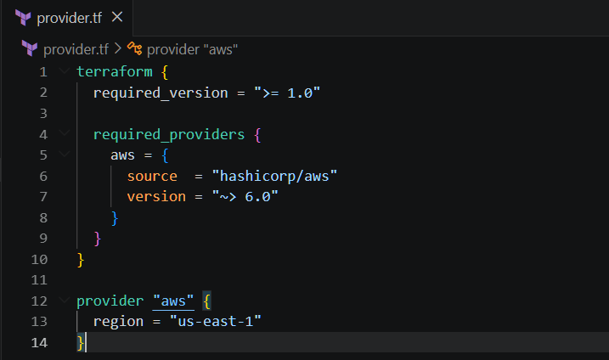
Why Do We Create provider.tf?
This file tells Terraform:
1. Which cloud provider to use (AWS)
2. Which AWS provider version to download
3. Which AWS region to deploy resources into
Terraform reads provider.tf and downloads the AWS provider plugin.
Run terraform init
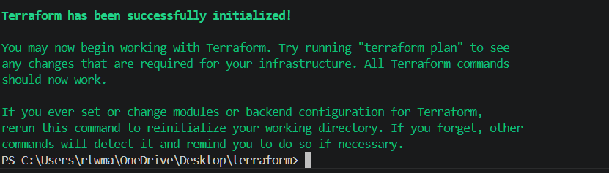
Now let’s create files inside VPC folder
Create variables.tf file
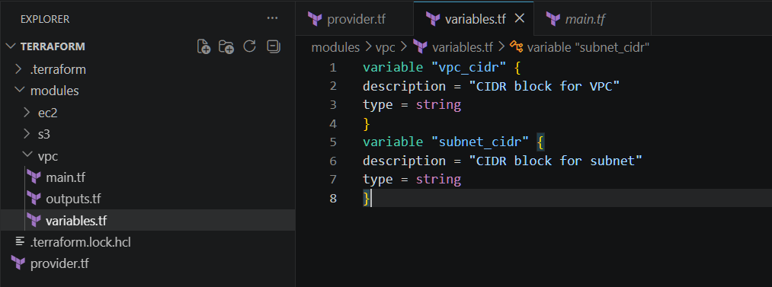
Create main.tf file
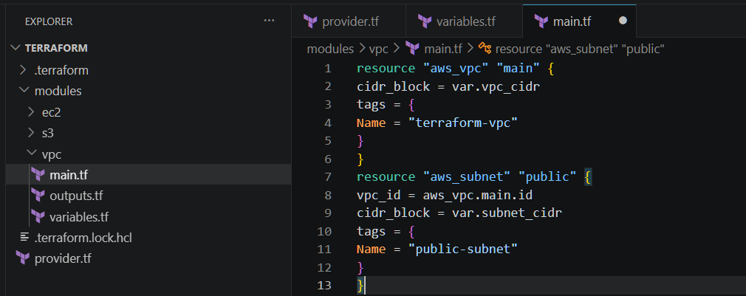
Create outputs.tf file
Now let’s create files inside ec2 folder
Create variables.tf file
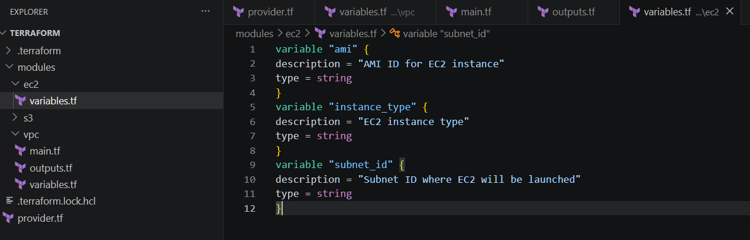
Create main.tf file
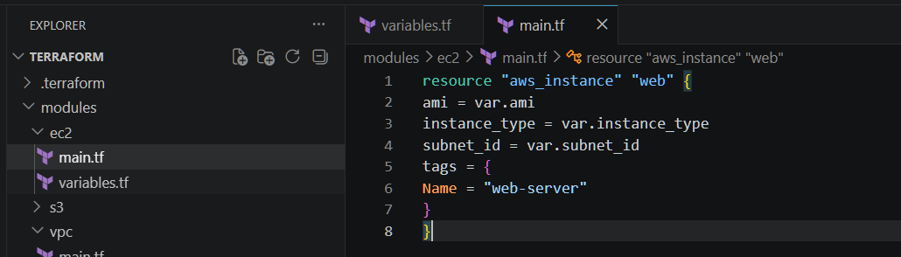
Create output.tf
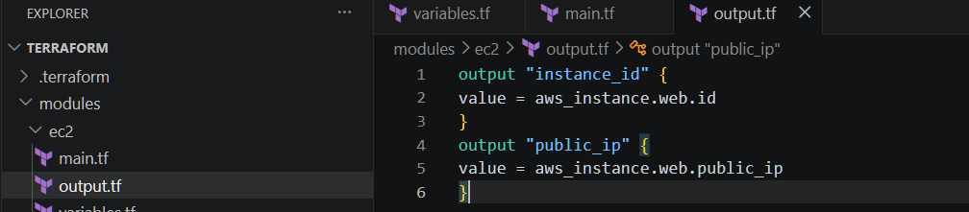
Now let’s create files inside s3
Create main.tf file
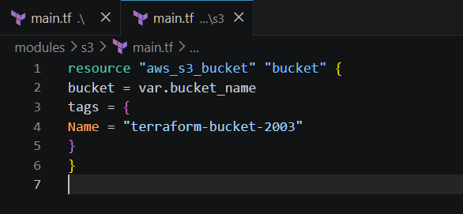
Create variable.tf file
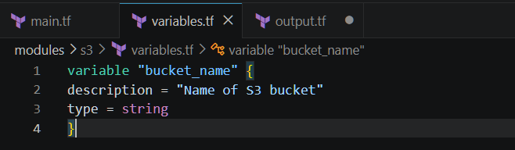
Create output.tf file
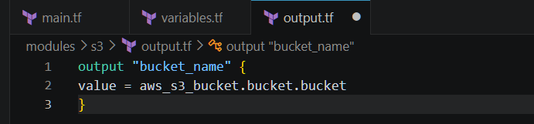
Now lets create main.tf file for root project
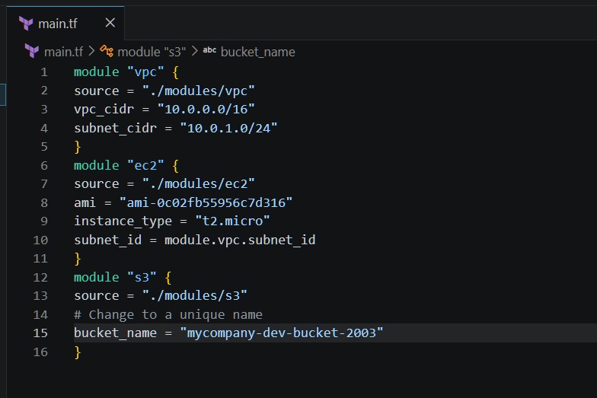
Create output.tf file
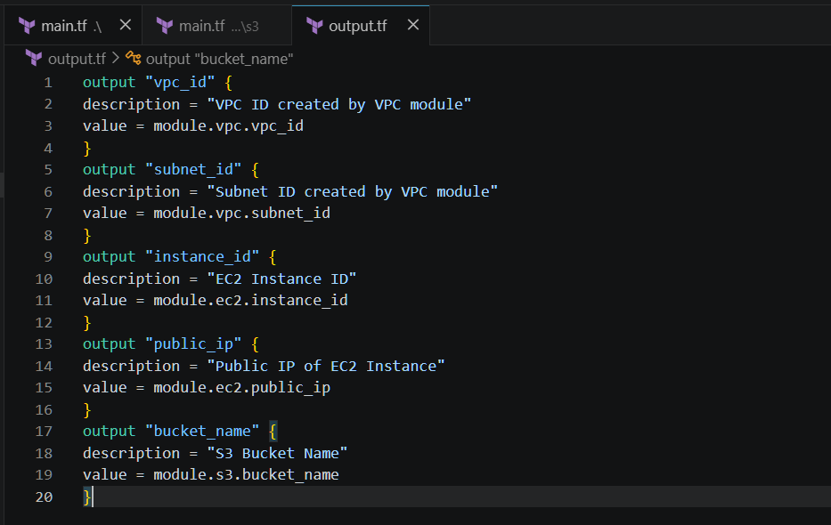
Terraform init
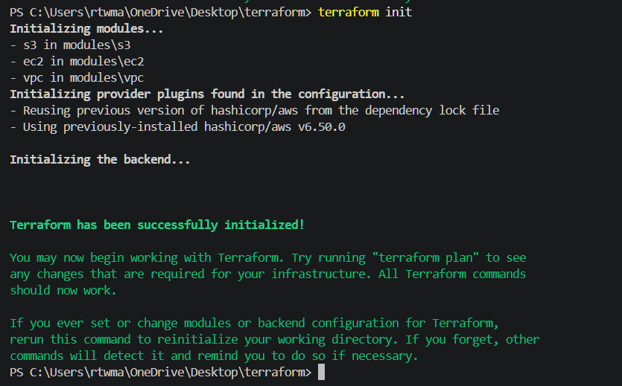
Validate configuration
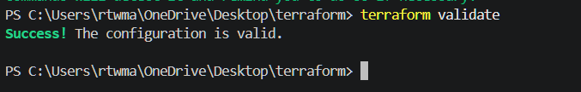
Terraform plan and terraform apply
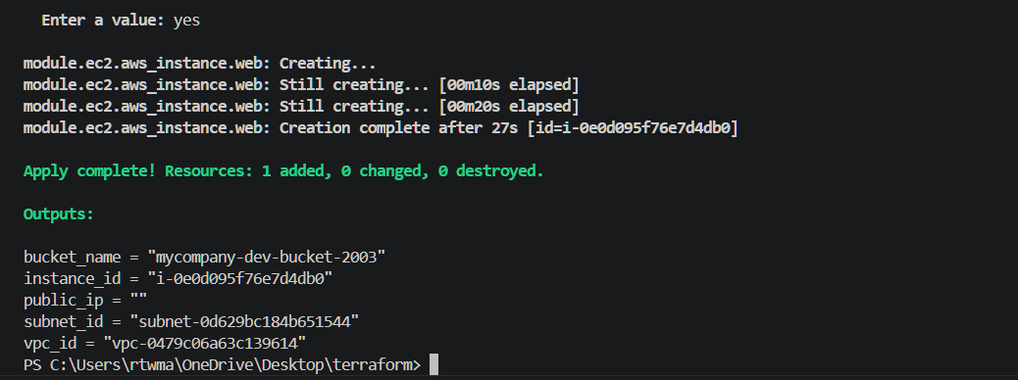

Instance created successfully
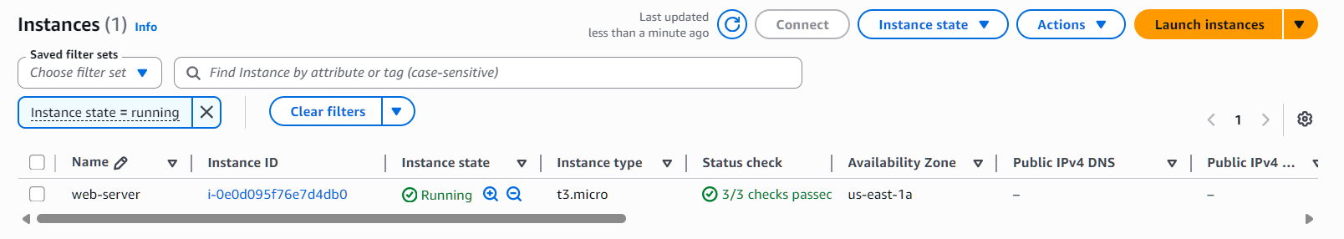
S3 bucket created
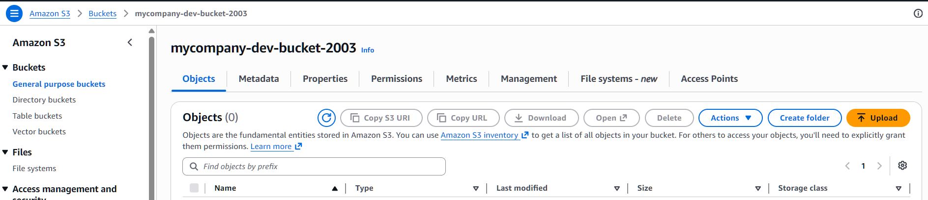
VPC created successfully
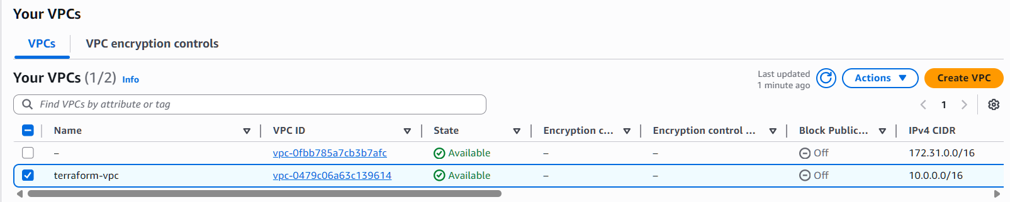
4). Provision EC2 for 3 different environments (Dev, Staging, and Prod) using Terraform workspaces.
Let’s create terraform-workspace folder
Create provider.tf file
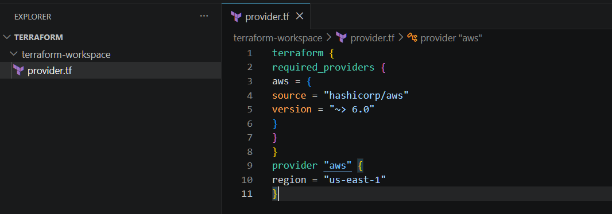
Create variable.tf file
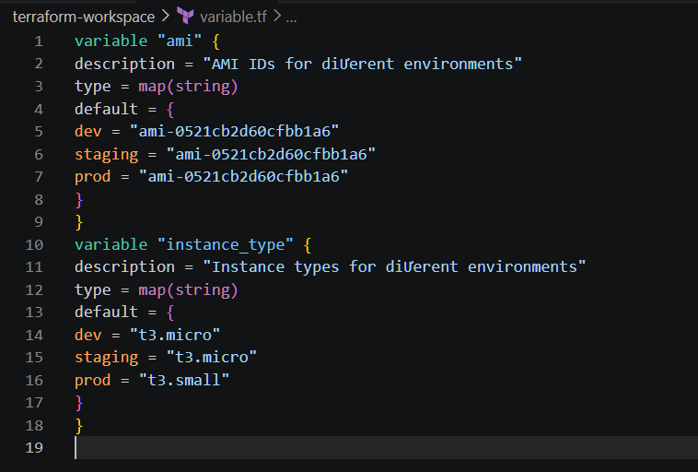
Create main.tf file
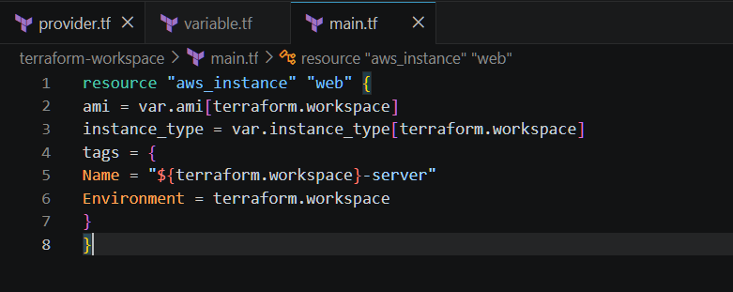
Create output.tf
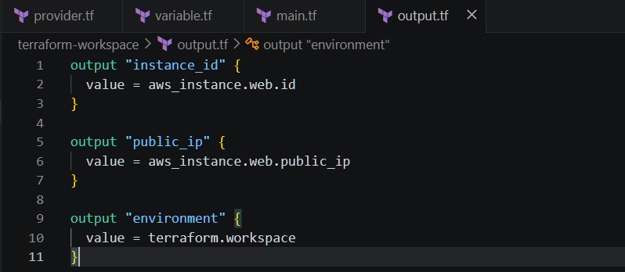
Terraform init
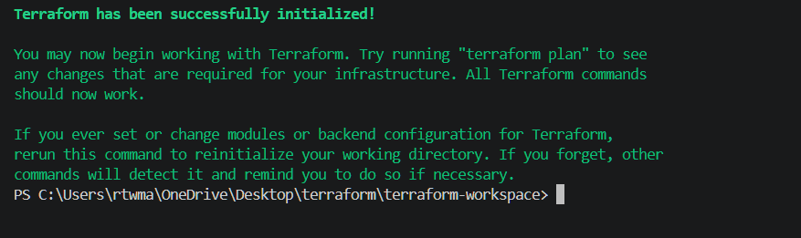
Create the below workspaces
Dev workspace:- terraform workspace new dev
Staging workspace:- terraform workspace new staging
Prod workspace:- terraform workspace new prod
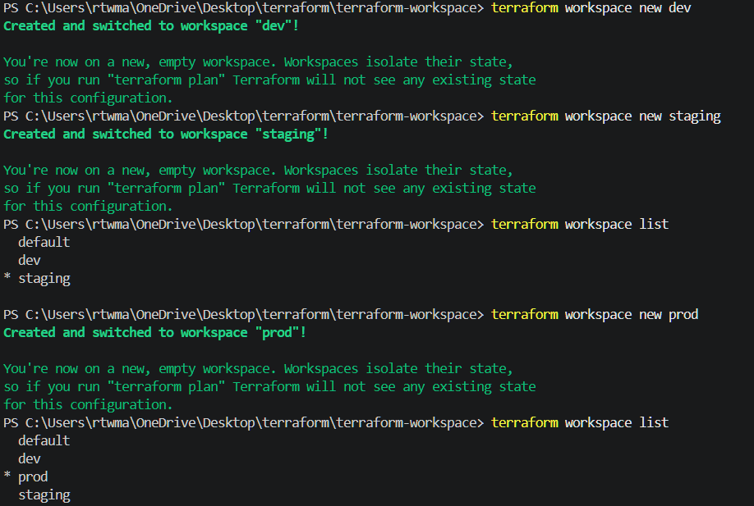
Switch to Dev
terraform workspace select dev
terraform workspace show – To show the current workspace
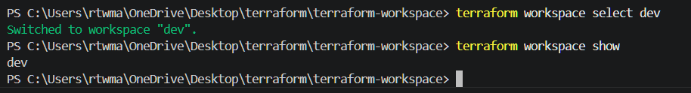
Terraform plan and terraform apply
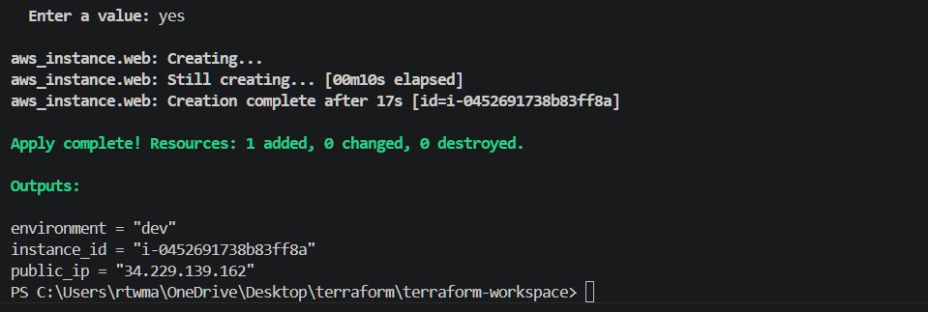
Lets switch to staging environment
terraform workspace select staging
Lets create staging ec2 instance
Terraform apply
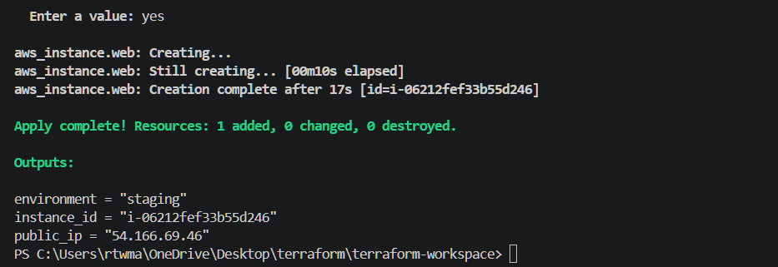
Now lets switch to prod environment
terraform workspace select prod
Lets create prod ec2 instance
terraform apply
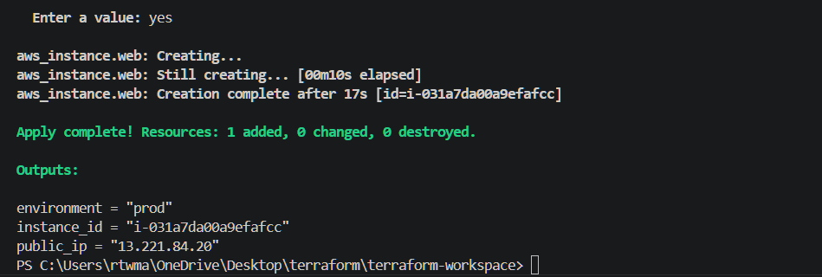
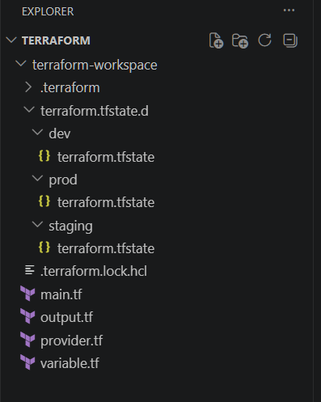
Instances are created successfully
